- Power up the Quad, you will find:
DSO203 MiNI DSO SYS Version 1.XX
DSO203 MiNI DSO APP Version 2.XX
This is your firmware version
- Download the firmware version you want to upgrade, from
http://www.seeedstudio.com/forum/viewtopic.php?f=22&t=1929
or:
http://garden.seeedstudio.com/index.php?title=DSO_Quad:Upgrading_Firmware#Firmware_List
and, then unzip the source.
For eg: you have download the sys1.37 and then unzip it:
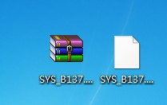
- Power up the Quad , with pressing the “>||” button
The Quad will be :
Please copy .hex/,bin file to DFU virtual USB disk.

And , a virtual disk will appear:

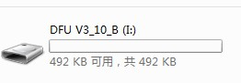
- When you are upgrading sys or app , Copy the sys_XXX.hex(or app_XXX.hex) to the virtual disk .the disk will auto reset ,and the file name changes to :
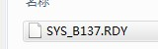
- Restart the Quad , the upgrading of app or sys finishes.
- When you upgrade the FPGA firmware , you need to first copy the .ADR file , after the auto reset, the name changes to :
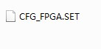
And , then the .bin file, after the auto reset, the name changes to :

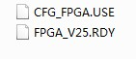
After reset of Quad , the upgrading of FPGA firmware finishes.

